
Sensor
Temperature Sensor

Aya mohamed
BOSINA SAAD
HABIBA AHMED
Hanin Mustafa
Fatma Mustafa

SenSor Report

what is the content ?
1-what is the sensor
2-The operation of sensor generally
3-The advantage and disadvantage of sensors
4-Types of sensors
5-Temperature sensor
- Operation
-Advantage and Disadvantage
-Types
-Circuit and characteristics

What is Sensor

A sensor is a device that produces an output signal for the purpose of sensing a physical phenomenon.

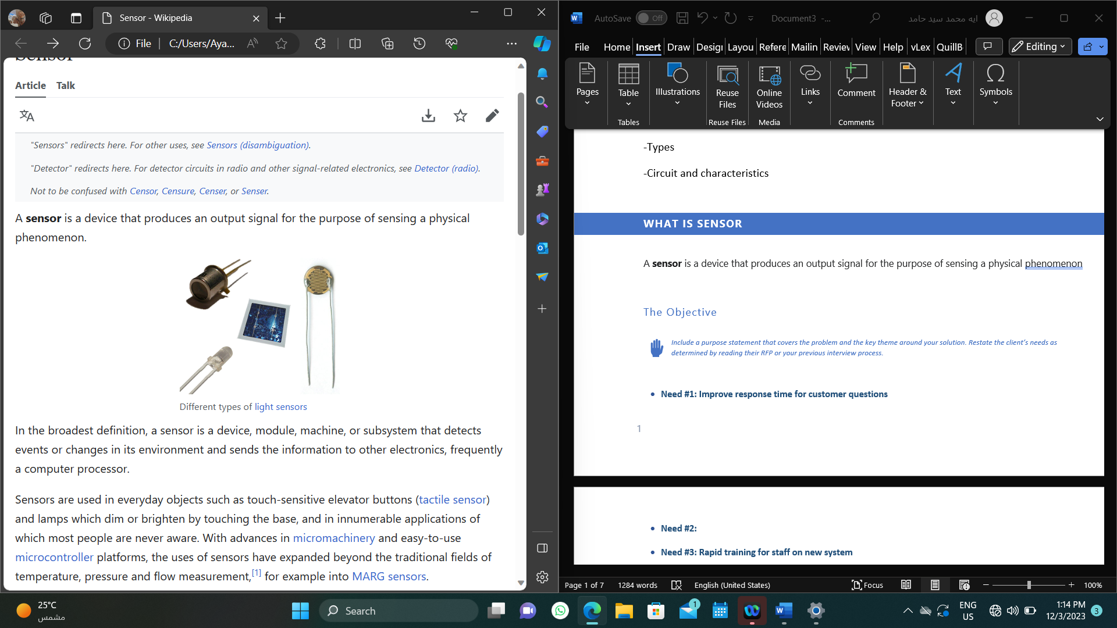
- In the broadest definition, a sensor is a device, module, machine, or subsystem that detects events or changes in its environment and sends the information to other electronics, frequently a computer processor.

How sensors work

A sensor converts the physical action to be measured into an electrical equivalent and processes it so that the electrical signals can be easily sent and further processed. The sensor can output whether an object is present or not present (binary) or what measurement value has been reached (analog or digital).

The main components of a sensor
A sensor consists of three main components:
(1) The sensing section contains the sensor itself which is based on a particular technology. The variety of technologies means you can select a sensor technology which fits your application.
(2) The processing circuitry converts the physical variable into an electrical variable.
(3) The signal output contains the electronics connected to a control system

advantage and disadvantage

Advantages of Sensors| pros of Sensors
- By offering feedback to the control systems, sensors make automation possible.
- Sensors can automate tasks and procedures, improving accuracy and performance.
- Real-time environmental data is gathered via sensors.
- Sensors can be used to monitor and control structures from a distance.
- Many sensors are designed to provide accurate readings.
- Sensors can improve safety.
Disadvantages of Sensors| Cons of Sensors
- Sensors need to be calibrated and maintained on a regular basis to ensure reliable readings.
- Environmental factors including temperature, humidity, and electromagnetic interference can affect how sensitive the sensor is.
- Some sensors may have a delayed response time.
- Many sensors need a power supply.
- Sensors may also have restricted ranges.

Types of SENSORS

There are many different types of sensors:

- Temperature sensors
- Pressure sensors
- Touch sensors
- Image sensors
- Motion sensors
- Light sensors
- Vibration sensors

The various sensor technologies help you in detecting or measuring objects. Depending on the technology the sensors output a switching signal or a measurement value:

- Inductive sensors generate an electromagnetic field. This in turn generates eddy currents in objects made of metal. The sensor detects this change.
- Capacitive sensors generate a capacitive measuring field. An entering object results in a change to the measuring field. The sensor responds to this change.
- Photoelectric sensors (light curtains) always consist of an emitter and a receiver. There are diffuse, retro-reflective, and through-beam types.
- Ultrasonic sensors send out a sound pulse in the inaudible range. The echo from the object is processed.
- Magnetic field sensors detect an external magnet. The field strength generated by the magnet is processed.
- Magneto strictive sensors detect the position of an external magnet using propagation time measurement.

What ARE a Temperature Sensors

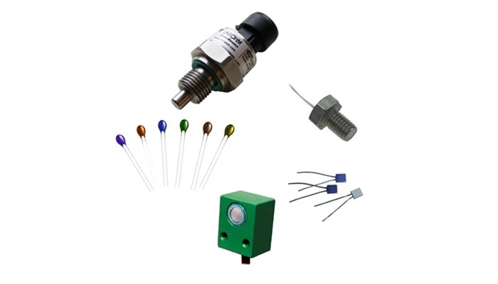 A temperature sensor is a device used to measure temperature. This can be air temperature, liquid temperature, or the temperature of solid matter.
There are different types of temperature sensors available, and they each use different technologies and principles to take the temperature measurement.

How temperature sensor work
Temperature sensors measure temperature readings via electrical signals. They contain two metals that generate an electrical voltage or resistance when a temperature change occurs.
The sensor plays a vital role in maintaining a specific temperature for a variety of industries, including medical applications, HVAC systems, and electrical appliances in our homes. Temperature sensors are critical for accuracy and temperature control in industries like these.
Temperature sensors work by measuring the voltage across the diode terminals. When the voltage increases, the temperature also increases, which is then followed by a voltage drop between the transistor terminals and the emitter (in a diode).
The sensors come in different types, which are categorized based on their connection. There are two main categories when it comes to temperature sensors, depending on the type of application being used or the industry you are working in:
- Contact Temperature Sensors
- Non-contact Temperature Sensors
Contact Temperature Sensors
Contact temperature sensors measure the degree of hotness or coldness of an object or substance via direct contact. They are generally used to detect a wide range of temperatures in different solids, liquids, or gases.
Non-Contact Temperature Sensors
These temperature meters are never in direct contact with an object or substance; therefore, they are widely used in hazardous environments such as power plant industries. They measure how hot or cold something is via radiation emitted by a heat source.

Different Types of Temperature Sensors
Thermistors
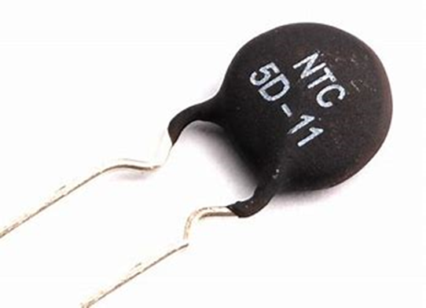
can be very small in size. They consist of a sensing element which can be either glass or epoxy coated and have 2 wires so they can be connected to an electric circuit. They measure temperature by measuring the change in resistance of the electric current. Thermistors are available as either NTC or PTC and are often low cost.
RTDs or Resistance Temperature Detectors
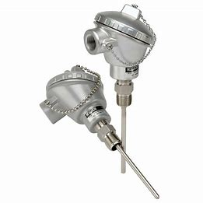
work in a similar way to Thermistors and measure ohmic resistance to measure temperature. They are connected to a circuit in a similar way to a thermistor, but they have a much wider temperature range and can measure extreme temperatures.
Thermocouples
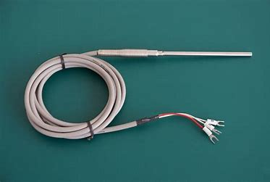
use two conductors, made up of different metals that are joined at the end to form a junction. When this junction is subjected to heat, a voltage is produced that is directly proportional to the temperature input. They are highly versatile as different metal combinations allow for different measurement ranges; however, they lack the fine accuracy of NTC’s and RTD’s, making them the least precise out of the three types.

What is a Temperature Sensor Used for?

Temperature sensors are used to measure temperature in many different applications and industries.
Industrial Applications – Monitoring various machinery and environments, power plants, manufacturing.
Scientific and laboratory applications – Science and biotech monitoring.
Medical Applications – Patient monitoring, medical devices, gas analysis, thermodilution cardiac catheters, humidifiers, ventilator flow tubes, dialysis fluid temperature.
Motorsport – Exhaust gas, inlet air temperature, oil temperature and engine temperature measurements.
Domestic appliances – Kitchen appliances (ovens, kettles etc) as well as white goods.
HVAC applications – Heating ventilation and air conditioning devices either commercial or domesticated.
Transit – Refrigerated vans and lorries

Considerations when selecting a temperature sensor for your application
When selecting a temperature sensor for use in your application you should take the following into consideration.
Temperature range – Different temperature sensors can measure different ranges and might be more accurate over a certain range. Make sure you check the range of the temperature sensor and the expected range of your application before purchasing. The range of the temperature sensor should be available on the datasheet.
Accuracy and stability – Your application may require a certain degree of accuracy; thermocouples have a higher variance in long term stability compared to thermistors and RTDs, so this is something to be aware of. The temperature sensor with the highest accuracy tends to be the glass coated NTC thermistors.
Size and Package – The space available within the application will influence the type of temperature sensor selected. If space is limited, then a smaller device will be required. Package style is also important as this will determine how the temperature sensor is connected into the application and how the temperature will be measured.

Advantage and Disadvantage of Temperature Sensor
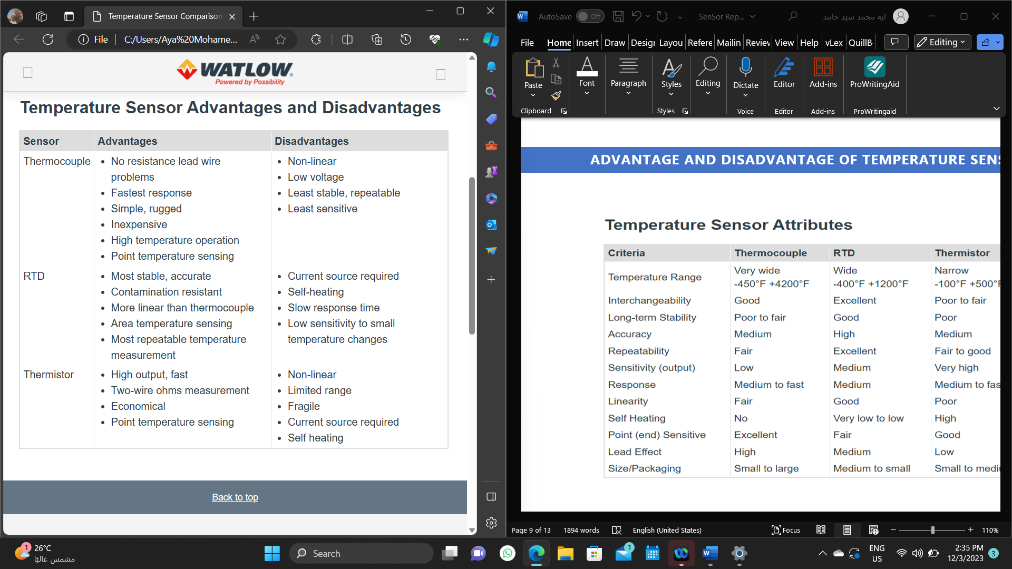
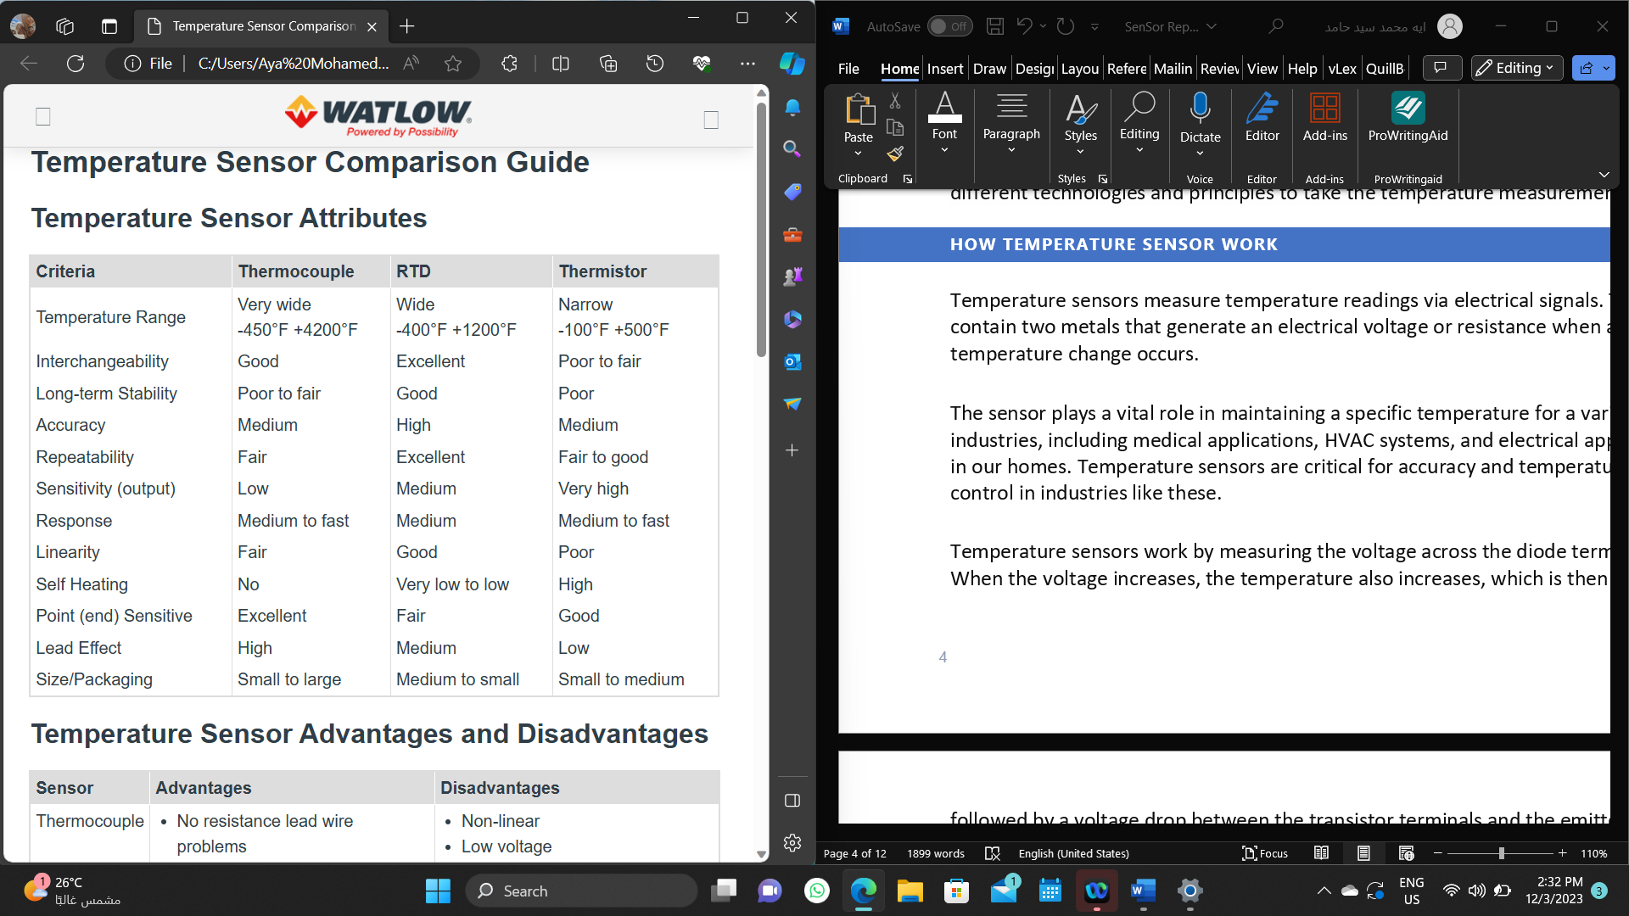

Temperature Sensor Characteristics

When selecting a sensor, understand the impact of each characteristic on your measurements and be sure to select a sensor that aligns closely with your project requirements. Use the following characteristics to define your temperature sensor capabilities and performance. These characteristics apply to all temperature sensor types but with some caveats and corner cases. Table 2 compares the different characteristics of the three common sensors.
After selecting the temperature sensor, you will use, thermocouples, RTDs, or thermistors, review further sensor considerations before choosing the right sensor for your applications

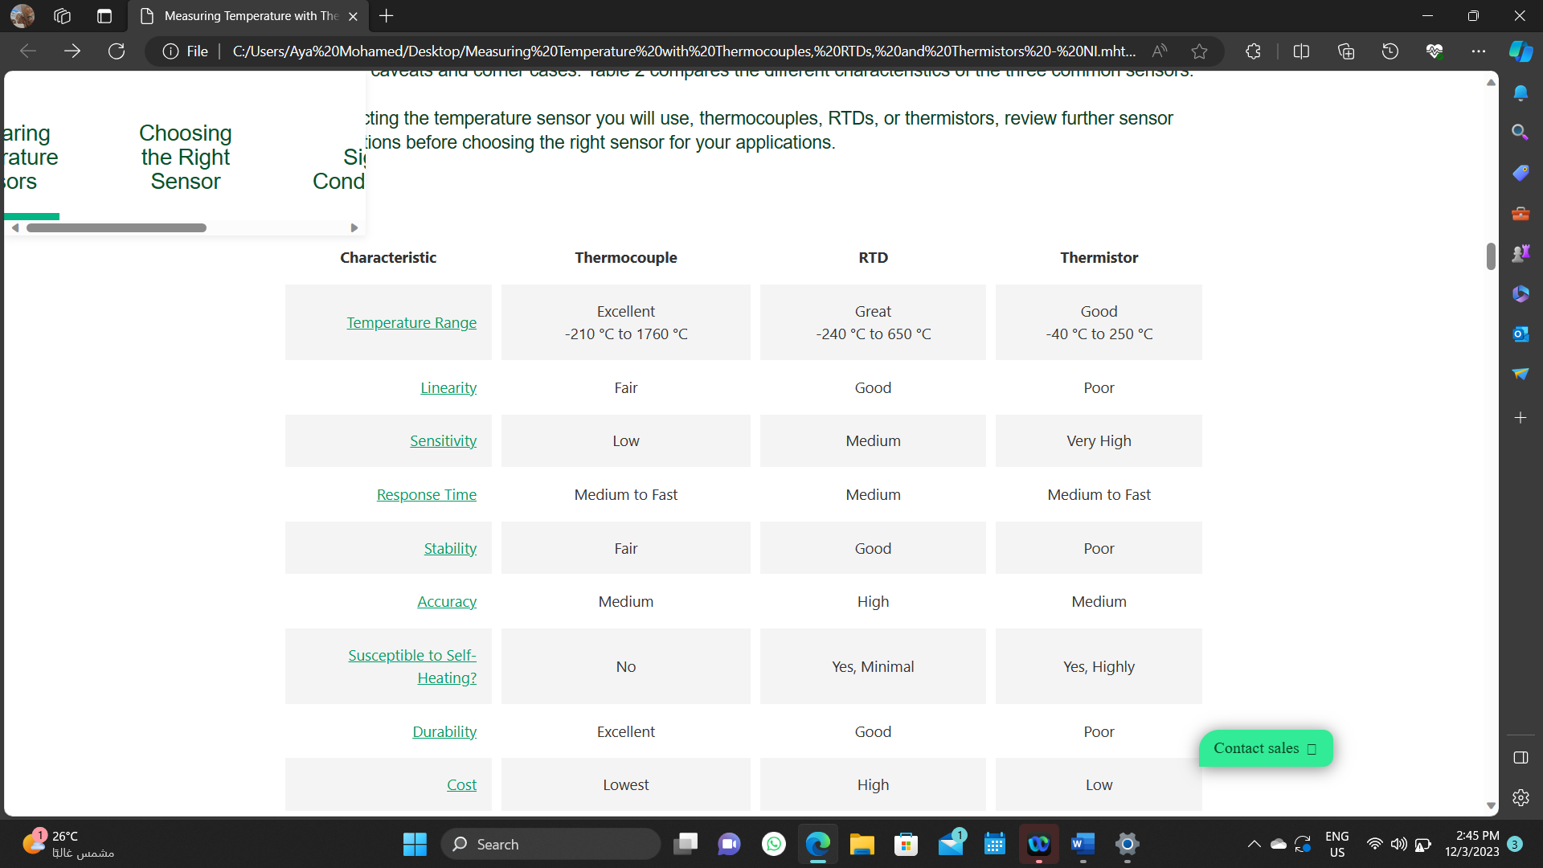

Sensitivity
The sensitivity of a given sensor indicates the percent change in measurable output for a given change in temperature. A more sensitive sensor, like a thermistor, can more easily detect small changes in temperature than a less sensitive sensor, like a thermocouple.

This sensitivity, however, comes at the expense of linearity. This can be an important factor when determining the ideal sensor choice for the temperatures you are measuring. If you intend to capture fraction-of-a-degree changes over a small temperature range, a thermistor or an RTD is more ideal. For capturing larger temperature changes over a wider range of temperatures, a thermocouple may suffice. Figure 4 gives a relative idea of the voltage.

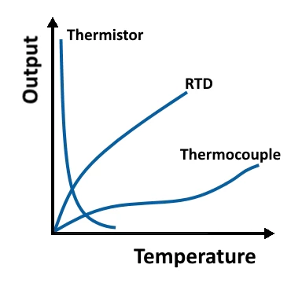

Response time
Response time is the measure of time a sensor takes to respond to a change in temperature. Many factors can cause response times to increase or decrease.

A larger RTD or thermistor, for example, has a slower response time than a smaller one. In exchange for this drawback and poorer thermal shunting, a larger RTD or thermistor is less susceptible to self-heating
errors. Similarly, ungrounded thermocouple junctions provide a slower response time in exchange for electrical isolation. Figure 5 shows the relative difference in response times for ungrounded and grounded thermocouples.
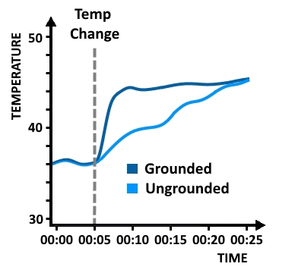

Supplied Material
The following materials are to be supplied by Northwind Traders for this project. For OLSON HARRIS LTD. to meet project milestones, this material must be supplied on schedule. The due dates included in the following table represent our best guess based on current proposed project dates:
Materials to be supplied by Northwind Traders | Due Date*
User data | 12/31/22
*We cannot be responsible for cost overruns caused by client’s failure to deliver materials by agreed-upon due dates.

Expected Results
 | Describe the results expected from the project and why your approach will achieve those results.

We expect our proposed solution to Northwind Traders ’s requirements to provide the following results:

Financial Benefits
- Result #1: Boost engagement
- Result #2: Grow sales
- Result #3: Retain customers

Technical Benefits
- Result #1: Larger demographic
- Result #2: Platform diversification
- Result #3: Ease of access

Other Benefits
 | Use this section to describe less tangible benefits such as increased morale or improved customer satisfaction.

Pricing
The following table details the pricing for delivery of the services outlined in this proposal. This pricing is valid for ## days from the date of this proposal:
Services Cost Category #1 | Price
Consultation services | $500.00
Total Services Category #1 Costs | $12,000
Services Cost Category #2
Facilities
License Fees
Equipment Rental
Training
Travel
Marketing
Shipping/Handling
Total Services Category #2 Costs | $6,000
Services Cost Category #3 | $500
Total Services Category #3 Costs | $500
Total | $19,000
Sample Disclaimer: Disclaimer: The prices listed in the preceding table are an estimate for the services discussed. This summary is not a warranty of final price. Estimates are subject to change if project specifications are changed or costs for outsourced services change before a contract is executed.

Qualifications
OLSON HARRIS LTD. is continually proven to be an industry leader for high quality/guaranteed product/service in the following ways:
 | Describe what sets your company apart from your competition (your unique selling proposition).

- Vision
- Inspiration
- Flexibility

 | Describe the strengths of your company, focusing on specializations that are most relevant for this project. As appropriate, include additional strengths of your unique selling proposition that provide benefits the customer may not have articulated.  Identify qualifications that support your ability to address specific client needs for the project.  Provide information that shows how you can meet the required schedule, such as staffing/subcontractors and percentage of time devoted to the project.

Conclusion
 | Close out the proposal with a statement that demonstrates your concern for the client and their needs, your expertise, and your willingness to help them solve the issues in question. Include any expected next steps and note the ways they can get in touch with you.

We look forward to working with Northwind Traders and supporting your efforts to improve your sales cycle with integrated CRM, JIT Inventory management, and training and support services. We are confident that we can meet the challenges ahead, and stand ready to partner with you in delivering an effective IT support solution.
If you have questions on this proposal, feel free to contact Michelle at your convenience by email at olson@example.com or by phone at (123) 456-7890. We will be in touch with you next week to arrange a follow-up conversation on the proposal.
Thank you for your consideration,
Michelle Wattz
VP of Sales & Marketing

